(P4) describe what data elements are and why they are important
Data elements:
- checksum - cyclic redundancy check (CRC)
Research: The cyclic redundancy check, or CRC, is a technique for detecting errors in digital data, but not for making corrections when errors are detected. In the CRC method, a certain number of check bits, often called a checksum, are appended to the message being transmitted. The receiver can determine whether or not the check bits agree with the data. If an error occurred, the receiver sends a “negative acknowledgement” (NAK) back to the sender, requesting that the message be retransmitted.
The technique is also sometimes applied to data storage devices, such as a disk drive. In this situation each block on the disk would have check bits, and the hardware might automatically initiate a reread of the block when an error is detected, or it might report the error to software.
Comment:
- Frames and packets
Research: Computer networks do not dedicate a single wire to each pair of communicating computers. Instead, the computers share the hardware. To avoid delays, networks limit the amount of data that a computer can transmit on each turn. This is called packet switching, and the unit of data that can be transferred is called a packet.
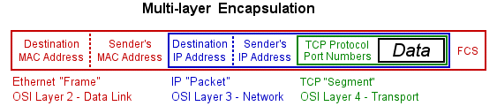
This diagram shows how the MAC and IP addresses are used on an Ethernet based LAN. It also illustrates the theory behind how "encapsulation" is used to build a frame and how they apply to the OSI layers.
Comment:
- Datagrams
Research: A datagram is a single transmission that stands by itself. They are often known as unreliable datagrams because there is no guarantee that they will reach their destination. It is up to a higher protocol or application to verify that a datagram reaches its destination. Streaming media (audio/video/voice) often use datagrams because it doesn't really matter if a few are lost in transmission
Comment:
- Addresses
Research: A network address serves as a unique identifier for a computer on a network. When set up correctly, computers can determine the addresses of other computers on the network and use these addresses to send messages to each other.
Comment:
- Sequence numbers
Research: A sequence is a collection of items or characters which appear in a particular order often referred to as a string. They are used for identification and error correction.
Comment:

Summary
Data elements are terms that we use to describe functions carried out in the computational process such as over networks. As with protocols it is important to define these processes so that some standardization of these functions can take place across various networks.

